A-PLANET Pilot study 1 Madrid, analysis of the choice experiment

*This version: December 2, 2022*

This document provides some analysis of the choice experiment data from the first pilot survey in Spain conducted in 2022. We will not show other results based on the same questionnaire, except for some cases where these are relevant for understanding the choice experiment results.

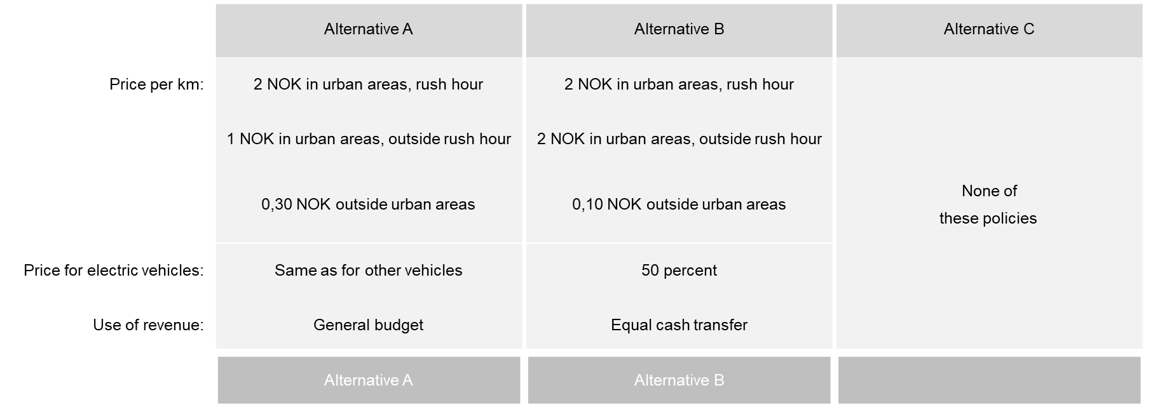

Figure 1. Example of choice task in the choice experiment

The table below shows to what extent other covariates differ between the subsamples that received different information treatments, as well as the control group. There are some differences. For instance, the share of respondents in Madrid is higher in the two last columns. However, the difference is not statistically significant. (The *p* value of the difference between those who received the third information treatment and the control group is 0.12 based on a two-sided test.)

Table 1. Balance of covariates across the three information treatments and the control group

|  |  |  |  |  |
| --- | --- | --- | --- | --- |
|  | (1) | (2) | (3) | (4) |
|  | Control | Info 1 | Info 2 | Info 3 |
| Madrid | 0.58 | 0.58 | 0.69 | 0.71 |
| Age | 27.39 | 26.55 | 26.74 | 26.50 |
| Woman | 0.64 | 0.59 | 0.49 | 0.53 |
| Car user | 0.35 | 0.43 | 0.23 | 0.25 |
| Car owner | 0.38 | 0.45 | 0.29 | 0.25 |
| Car access | 0.49 | 0.39 | 0.53 | 0.56 |
| Observations | 72 | 69 | 70 | 72 |

In the choice experiment, the attributes of the two policy alternatives are:

* Price, urban peak hour (EUR)
* Price, urban off-peak hour (EUR)
* Price, non-urban (0.1 EUR)
* EV discount (between 0 and 1)
* Use of revenues
  + General budget (dummy, baseline)
  + Equal cash transfer (dummy)
  + Cash transfer for low-income citizens (dummy)
  + Investments in roads (dummy)
  + Investments in public transport and active travel (dummy)

# Descriptive analysis

Correlation between attribute values (this should be fixed in the next round)

The figure below gives some insight into how respondents behave in the choice experiment. The left panel shows that in most cases, respondents pick one of the two policy alternatives (1 or 2), but in about 22 percent of the cases, they pick the status quo alternative (3). The right panel shows that very few respondents always pick alternative 1 or always pick alternative 2. This suggests that respondents are actually evaluating the attributes of the alternatives. However, a non-negligible share always picks alternative 3, which is not unexpected.

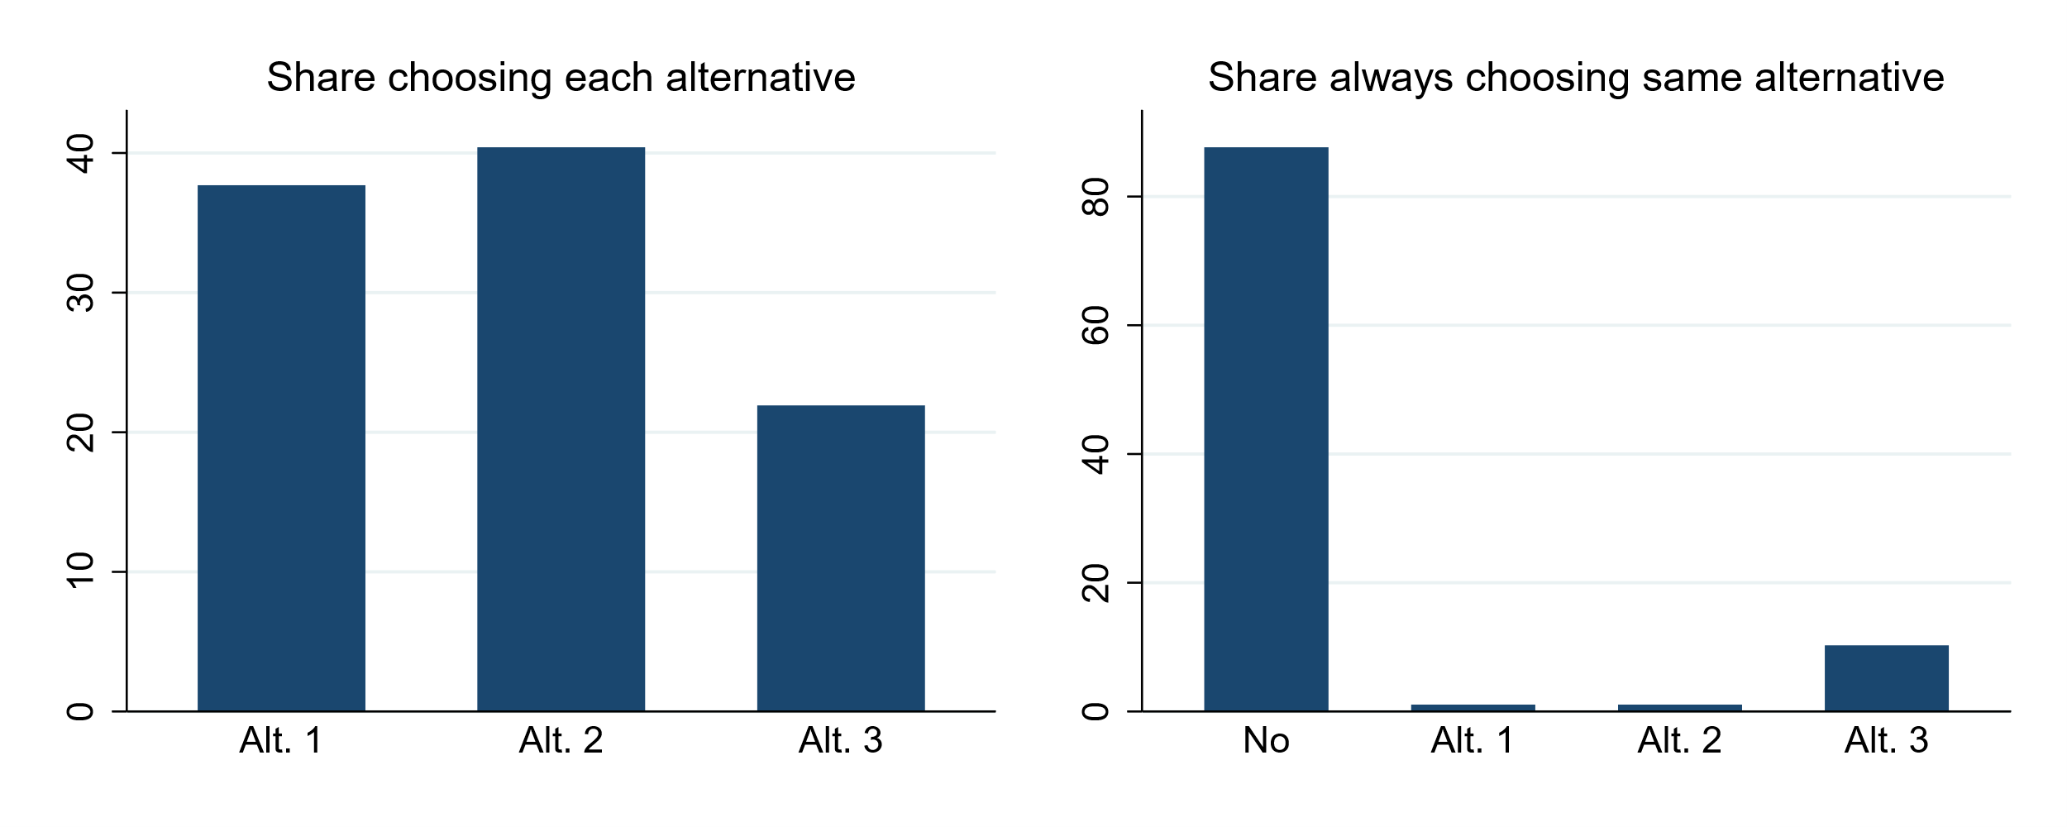

Figure 2. General choice behaviour in the choice experiment. Full sample.

The next figure shows how the probability that a policy alternative (1 or 2) is chosen depends on the price level in that alternative. The figure suggests that respondents on average prefer lower prices, with somewhat more mixed results for the price outside urban areas.

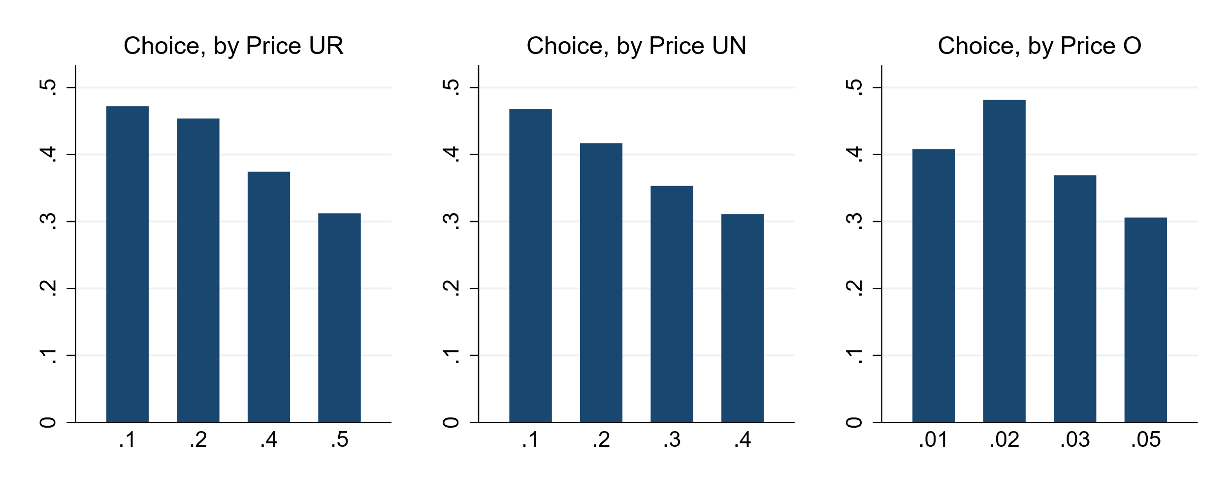

Figure 3. Choice behaviour in the choice experiment, by price level. Full sample.

The pattern is very similar if we only include the sample of respondents from Madrid.

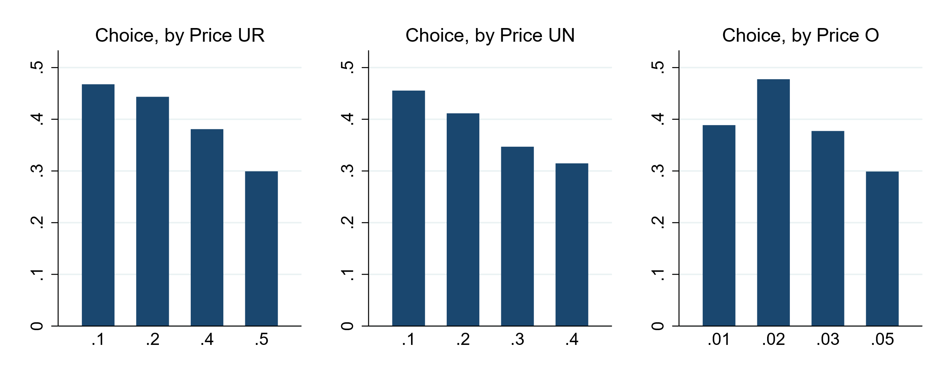

Figure 4. Choice behaviour in the choice experiment, by price level. Only respondents from Madrid.

Descriptive evidence on the treatments

# Discrete choice models

We analyze the choice experiment using a multinomial logit model. This means that for each choice situation, we take into account both how the two policy alternatives score compared to each other and compared to the status quo option.

For respondent *i*, the utility function of each of the two policy (road pricing) alternatives *j*={1,2} is:

$$U_{ij}=α+β_{1}⋅{PriceUR}_{ij}+β_{2}⋅{PriceUN}_{ij}+β_{3}⋅{PriceO}_{ij}+β_{4}⋅EV_{ij}+γ_{2}⋅Revenue2+γ_{3}⋅Revenue3_{ij}+γ_{4}⋅Revenue4_{ij}+γ_{5}⋅Revenue5_{ij}+λx_{i}+ε_{ij}$$

where $x_{i}$ is a vector of additional explanatory variables (including the information treatments). In some models, we also include interaction effects of the attributes and elements of $x_{i}$.

The utility of the status quo alternative (j=3) is simply:

$$U_{i3}=ε_{i3}$$

(Alternatively, we could include $α$ and $λx_{i}$ in the utility of the status quo alternative. This would only reverse the sign of the effects.)

# Baseline results

The table below shows the results from different models that only include the attributes of the alternatives and no additional explanatory variables. This gives us the estimated preferences of the ‘average’ respondent in our sample, in terms of socio-demographic characteristics and attitudes. Note that this sample includes all the information treatments as well as the control group.

With respect to the different models, the results show the following:

* The respondents have no significant preference for one of the two policy alternatives relative to the other (column 1).
* There is no significant effect of the price in off-peak hours (columns 1 and 2), possibly due to high correlation with the peak-hour price. When using instead the average of peak and off-peak price as a single variable (columns 3-6), the effect becomes significant.
* Results are similar when using the full sample or only the Madrid sample, except for the preference for spending the revenue on road investments (columns 3 and 4). This could be because the information treatments are not perfectly balanced between the two samples (Madrid and non-Madrid)
* There is a significant effect of the EV discount both when including this a separate variable (columns 3 and 4) and when interacting it with the price in urban areas (column 5 and 6). However, the effect of the interaction with the price outside urban areas is not significant. The price in urban areas has a negative effect even if the price for EVs is zero.

In the following, we consider model (3)/(4) our preferred specification.

Table 2. Results from choice experiment, model only including choice task attributes as explanatory variables

|  |  |  |  |  |  |  |
| --- | --- | --- | --- | --- | --- | --- |
|  | (1) | (2) | (3) | (4) | (5) | (6) |
|  | All | All | All | Madrid | All | Madrid |
|  |  |  |  |  |  |  |
| Alt. 1 or 2 | 0.679*** | 0.707*** | 0.742*** | 0.714*** | 1.031*** | 1.013*** |
|  | (0.196) | (0.194) | (0.194) | (0.231) | (0.184) | (0.224) |
|  |  |  |  |  |  |  |
| Alt. 2 | 0.058 |  |  |  |  |  |
|  | (0.057) |  |  |  |  |  |
|  |  |  |  |  |  |  |
| Price, urban peak-hour | -1.966*** | -1.950*** |  |  |  |  |
|  | (0.432) | (0.431) |  |  |  |  |
|  |  |  |  |  |  |  |
| Price, urban off-peak | -0.616 | -0.630 |  |  |  |  |
|  | (0.676) | (0.675) |  |  |  |  |
|  |  |  |  |  |  |  |
| Price, urban average |  |  | -2.944*** | -2.857*** | -1.444*** | -1.409** |
|  |  |  | (0.349) | (0.426) | (0.510) | (0.613) |
|  |  |  |  |  |  |  |
| Price, non-urban | 0.193 | 0.189 | 0.223 | 0.272 | -0.175 | 0.004 |
|  | (0.248) | (0.247) | (0.245) | (0.305) | (0.461) | (0.552) |
|  |  |  |  |  |  |  |
| EV discount | 0.657*** | 0.659*** | 0.638*** | 0.663*** |  |  |
|  | (0.120) | (0.120) | (0.116) | (0.139) |  |  |
|  |  |  |  |  |  |  |
| EV price, urban |  |  |  |  | -2.579*** | -2.474*** |
|  |  |  |  |  | (0.715) | (0.861) |
|  |  |  |  |  |  |  |
| EV price, non-urban |  |  |  |  | 0.577 | 0.351 |
|  |  |  |  |  | (0.754) | (0.908) |
|  |  |  |  |  |  |  |
| Equal cash transfer | -0.025 | -0.024 | -0.001 | -0.113 | 0.049 | -0.062 |
|  | (0.137) | (0.137) | (0.133) | (0.164) | (0.133) | (0.164) |
|  |  |  |  |  |  |  |
| Low-income citizens | 0.378*** | 0.378*** | 0.401*** | 0.374** | 0.349*** | 0.318** |
|  | (0.131) | (0.131) | (0.128) | (0.161) | (0.129) | (0.162) |
|  |  |  |  |  |  |  |
| Road investments | 0.297** | 0.296** | 0.302** | 0.119 | 0.283** | 0.098 |
|  | (0.132) | (0.132) | (0.131) | (0.166) | (0.131) | (0.166) |
|  |  |  |  |  |  |  |
| PT/active travel | 0.963*** | 0.967*** | 0.970*** | 0.857*** | 0.908*** | 0.791*** |
|  | (0.132) | (0.132) | (0.131) | (0.160) | (0.130) | (0.161) |
| Observations | 5094 | 5094 | 5094 | 3258 | 5094 | 3258 |
| Final LL | -1717.80 | -1718.31 | -1719.02 | -1109.41 | -1717.57 | -1108.47 |

With respect to the preferences, the urban price coefficient is about 4,3 times as big as the EV discount coefficient (column 4), which means that respondents are equally happy with an 0.25 EUR reduction as they are with going from no EV discount to a full discount. Columns (5) and (6) also confirm that respondents would like to reduce the price both for EVs and non-EVs.

The urban price coefficient is about 3,3 times as big as the coefficient for spending the revenue on public transport and active travel. This means that such spending (compared to allocating the revenue to the general budget) is equivalent to reducing the price level by about 0.3 EUR.

There are no significant preference for or against higher prices outside urban areas when controlling for other attributes.

# Effect of the congestion and pollution treatment

The table below shows the effect of the information treatment where 1/4 of the respondents receive more information about the fact that road pricing could reduce congestion and local pollution. Here, we only include this treatment group and the control group.

First, we should note that in these results, there are hardly any differences between the results for the whole sample and the Madrid sample with respect to the preferences for road investments (columns 1 and 2). This suggests that the difference in the previous section is due to the beforementioned imbalances of the treatments.

Columns (1) and (2) only include the effect of the information treatment on the preference for the two policy alternatives (1 and 2). The effect is negative in the full sample and positive in the Madrid sample, but neither effect is statistically significant.

Columns (3) and (4) include an interaction effect of the treatment and the price in urban areas. Somewhat surprisingly, the effect is negative, which means that the aversion against high prices increases with this treatment. However, it is not statistically significant.

Columns (5) and 6) include an interaction effect of the treatment and EV discount. As could be expected, the EV discount becomes considerably less popular with this treatment. However, the effect is not statistically significant.

Also with PT funding

Table 3. Results from choice experiment, effect of information treatment with congestion and pollution

|  |  |  |  |  |  |  |
| --- | --- | --- | --- | --- | --- | --- |
|  | (1) | (2) | (3) | (4) | (5) | (6) |
|  | All | Madrid | All | Madrid | All | Madrid |
|  |  |  |  |  |  |  |
| Alt. 1 or 2 | 0.394 | 0.140 | 0.280 | -0.031 | 0.279 | 0.024 |
|  | (0.322) | (0.407) | (0.350) | (0.422) | (0.329) | (0.414) |
|  |  |  |  |  |  |  |
| Price, urban average | -2.446*** | -2.502*** | -2.051*** | -1.830** | -2.439*** | -2.424*** |
|  | (0.460) | (0.572) | (0.651) | (0.784) | (0.464) | (0.577) |
|  |  |  |  |  |  |  |
| Price, non-urban | 0.317 | 0.325 | 0.309 | 0.258 | 0.314 | 0.265 |
|  | (0.354) | (0.449) | (0.353) | (0.449) | (0.354) | (0.441) |
|  |  |  |  |  |  |  |
| EV discount | 0.617*** | 0.688*** | 0.618*** | 0.701*** | 0.864*** | 0.941*** |
|  | (0.174) | (0.228) | (0.174) | (0.227) | (0.222) | (0.285) |
|  |  |  |  |  |  |  |
| Equal cash transfer | 0.345* | 0.316 | 0.347* | 0.303 | 0.341* | 0.307 |
|  | (0.178) | (0.221) | (0.178) | (0.220) | (0.178) | (0.219) |
|  |  |  |  |  |  |  |
| Low-income citizens | 0.566*** | 0.650*** | 0.569*** | 0.635*** | 0.563*** | 0.633*** |
|  | (0.179) | (0.239) | (0.178) | (0.238) | (0.179) | (0.239) |
|  |  |  |  |  |  |  |
| Road investments | 0.582*** | 0.542** | 0.584*** | 0.531** | 0.588*** | 0.551** |
|  | (0.185) | (0.248) | (0.185) | (0.250) | (0.185) | (0.249) |
|  |  |  |  |  |  |  |
| PT/active travel | 1.190*** | 1.229*** | 1.191*** | 1.216*** | 1.192*** | 1.230*** |
|  | (0.196) | (0.260) | (0.196) | (0.262) | (0.197) | (0.261) |
|  |  |  |  |  |  |  |
| Info: Pollution/congestion | -0.319 | 0.141 | -0.088 | 0.538 | -0.089 | 0.351 |
|  | (0.339) | (0.455) | (0.431) | (0.586) | (0.378) | (0.490) |
|  |  |  |  |  |  |  |
| Price, urban average # Info: Pollution/congestion |  |  | -0.804 | -1.360 |  |  |
|  |  |  | (0.824) | (1.017) |  |  |
|  |  |  |  |  |  |  |
| EV discount # Info: Pollution/congestion |  |  |  |  | -0.500 | -0.460 |
|  |  |  |  |  | (0.356) | (0.449) |
| Observations | 2538 | 1476 | 2538 | 1476 | 2538 | 1476 |
| Final LL | -866.93 | -502.60 | -866.54 | -501.95 | -865.46 | -501.91 |

# Effect of the public revenue treatment

The table below shows the effect of the information treatment where 1/4 of the respondents receive more information about the importance of public revenues for public. Here, we only include this treatment group and the control group.

Columns (1) and (2) only include the effect of the information treatment on the preference for the two policy alternatives (1 and 2). The effect is positive both in the full sample and the Madrid sample, but neither effect is statistically significant.

Columns (3) and (4) include an interaction effect of the treatment and allocating the revenues to the general budget. The effect is positive and statistically significant, which means that, as expected, respondents are more in favor of allocating the revenues from road pricing to the general budget if the receive this information treatment. In the control group, respondents have a strong preference for earmarking the revenues to specific purposes (particularly public transport and active travel), while in the treatment group they are more indifferent.

Columns (5) and 6) also include interaction effects of the treatment and the urban price level as well as the EV discount. As could be expected, the EV discount becomes less popular with this treatment, but the effect of the price level also becomes more negative. However, neither effect is statistically significant. The interaction effect with the EV discount is also a bit smaller than in the previous section.

Table 4. Results from choice experiment, effect of information treatment with public revenues

|  |  |  |  |  |  |  |
| --- | --- | --- | --- | --- | --- | --- |
|  | (1) | (2) | (3) | (4) | (5) | (6) |
|  | All | Madrid | All | Madrid | All | Madrid |
|  |  |  |  |  |  |  |
| Alt. 1 or 2 | 0.702** | 0.351 | 0.374 | -0.143 | 0.190 | -0.298 |
|  | (0.321) | (0.392) | (0.342) | (0.415) | (0.378) | (0.444) |
|  |  |  |  |  |  |  |
| Price, urban average | -2.796*** | -2.555*** | -2.795*** | -2.638*** | -2.479*** | -2.324*** |
|  | (0.516) | (0.619) | (0.512) | (0.610) | (0.667) | (0.791) |
|  |  |  |  |  |  |  |
| Price, non-urban | 0.439 | 0.366 | 0.436 | 0.405 | 0.462 | 0.376 |
|  | (0.367) | (0.469) | (0.366) | (0.468) | (0.365) | (0.463) |
|  |  |  |  |  |  |  |
| EV discount | 0.730*** | 0.778*** | 0.726*** | 0.778*** | 0.898*** | 0.951*** |
|  | (0.152) | (0.179) | (0.151) | (0.177) | (0.225) | (0.285) |
|  |  |  |  |  |  |  |
| Equal cash transfer | -0.161 | -0.041 | 0.215 | 0.537* | 0.219 | 0.527* |
|  | (0.188) | (0.232) | (0.235) | (0.305) | (0.236) | (0.310) |
|  |  |  |  |  |  |  |
| Low-income citizens | 0.409** | 0.628*** | 0.780*** | 1.195*** | 0.791*** | 1.184*** |
|  | (0.172) | (0.214) | (0.224) | (0.308) | (0.226) | (0.314) |
|  |  |  |  |  |  |  |
| Road investments | 0.252 | 0.112 | 0.624*** | 0.699** | 0.630*** | 0.697** |
|  | (0.180) | (0.239) | (0.230) | (0.322) | (0.232) | (0.329) |
|  |  |  |  |  |  |  |
| PT/active travel | 0.945*** | 0.968*** | 1.317*** | 1.541*** | 1.327*** | 1.538*** |
|  | (0.187) | (0.235) | (0.240) | (0.330) | (0.242) | (0.333) |
|  |  |  |  |  |  |  |
| Info: Public revenues | 0.151 | 0.263 | 0.063 | 0.134 | 0.438 | 0.436 |
|  | (0.349) | (0.435) | (0.353) | (0.441) | (0.475) | (0.579) |
|  |  |  |  |  |  |  |
| General budget # Info: Public revenues |  |  | 0.692** | 1.004*** | 0.707** | 1.005*** |
|  |  |  | (0.280) | (0.360) | (0.283) | (0.370) |
|  |  |  |  |  |  |  |
| Price, urban average # Info: Public revenues |  |  |  |  | -0.726 | -0.562 |
|  |  |  |  |  | (0.917) | (1.081) |
|  |  |  |  |  |  |  |
| EV discount # Info: Public revenues |  |  |  |  | -0.371 | -0.309 |
|  |  |  |  |  | (0.301) | (0.369) |
| Observations | 2556 | 1620 | 2556 | 1620 | 2556 | 1620 |
| Final LL | -850.57 | -548.59 | -847.64 | -544.79 | -846.49 | -544.32 |

# Effect of the redistribution treatment

The table below shows the effect of the information treatment where 1/4 of the respondents receive more information about the importance of redistribution Here, we only include this treatment group and the control group.

Columns (1) and (2) only include the effect of the information treatment on the preference for the two policy alternatives (1 and 2). The effect is close to zero and not statistically significant.

Columns (3) and (4) include an interaction effect of the treatment and allocating the revenues to a cash transfer for low-income citizens. The effect is close to zero in the full sample and negative in the Madrid sample, but not statistically significant. We would have expected the effect to be positive.

Columns (5) and 6) also include interaction effects of the treatment and the urban price level as well as the EV discount. The first interaction effect is negative and marginally significant in the full sample, suggesting that information about redistribution increases aversion to higher prices. The interaction effect with the EV discount is also negative, but far from statistically significant.

Table 5. Results from choice experiment, effect of information treatment with redistribution

|  |  |  |  |  |  |  |
| --- | --- | --- | --- | --- | --- | --- |
|  | (1) | (2) | (3) | (4) | (5) | (6) |
|  | All | Madrid | All | Madrid | All | Madrid |
|  |  |  |  |  |  |  |
| Alt. 1 or 2 | 0.528 | 0.312 | 0.523 | 0.291 | 0.279 | 0.019 |
|  | (0.323) | (0.379) | (0.323) | (0.379) | (0.363) | (0.433) |
|  |  |  |  |  |  |  |
| Price, urban average | -3.089*** | -2.982*** | -3.087*** | -3.008*** | -2.260*** | -2.204*** |
|  | (0.521) | (0.647) | (0.522) | (0.641) | (0.676) | (0.819) |
|  |  |  |  |  |  |  |
| Price, non-urban | 0.422 | 0.597 | 0.423 | 0.603 | 0.408 | 0.555 |
|  | (0.340) | (0.442) | (0.341) | (0.443) | (0.341) | (0.436) |
|  |  |  |  |  |  |  |
| EV discount | 0.846*** | 0.760*** | 0.846*** | 0.759*** | 0.879*** | 0.910*** |
|  | (0.158) | (0.185) | (0.158) | (0.186) | (0.223) | (0.285) |
|  |  |  |  |  |  |  |
| Equal cash transfer | 0.155 | 0.122 | 0.155 | 0.114 | 0.155 | 0.108 |
|  | (0.195) | (0.241) | (0.195) | (0.240) | (0.194) | (0.241) |
|  |  |  |  |  |  |  |
| Low-income citizens | 0.513*** | 0.539** | 0.543** | 0.732*** | 0.499** | 0.659** |
|  | (0.194) | (0.253) | (0.218) | (0.275) | (0.217) | (0.279) |
|  |  |  |  |  |  |  |
| Road investments | 0.495** | 0.420* | 0.495** | 0.413 | 0.496** | 0.411 |
|  | (0.193) | (0.255) | (0.193) | (0.255) | (0.193) | (0.256) |
|  |  |  |  |  |  |  |
| PT/active travel | 1.183*** | 1.044*** | 1.184*** | 1.042*** | 1.185*** | 1.037*** |
|  | (0.187) | (0.219) | (0.187) | (0.220) | (0.188) | (0.220) |
|  |  |  |  |  |  |  |
| Info: Redistribution | 0.022 | 0.042 | 0.031 | 0.099 | 0.530 | 0.606 |
|  | (0.343) | (0.419) | (0.346) | (0.422) | (0.478) | (0.555) |
|  |  |  |  |  |  |  |
| Low-income citizens # Info: Redistribution |  |  | -0.057 | -0.354 | 0.034 | -0.251 |
|  |  |  | (0.258) | (0.318) | (0.269) | (0.338) |
|  |  |  |  |  |  |  |
| Price, urban average # Info: Redistribution |  |  |  |  | -1.676* | -1.424 |
|  |  |  |  |  | (0.943) | (1.098) |
|  |  |  |  |  |  |  |
| EV discount # Info: Redistribution |  |  |  |  | -0.059 | -0.250 |
|  |  |  |  |  | (0.328) | (0.388) |
| Observations | 2592 | 1674 | 2592 | 1674 | 2592 | 1674 |
| Final LL | -859.00 | -571.17 | -858.97 | -570.47 | -857.30 | -569.42 |

* p<0.1, ** p<0.05, *** p<0.01. Standard errors clustered on respondent.

# Association with car use

The table below shows the association with car use, defined as whether the respondent travels by car on the trip reported in the questionnaire. Being a car user has a negative effect on the probability of choosing the road pricing alternatives in all specifications. The effect is only statistically significant when we include the full sample and do not include other control variables, but the point estimate is similar also when other controls are included.

In terms of interaction effects, the most apparent result is that car users are less in favor of spending the revenues on public transport and active travel (column 4) compared to non-car users. However, this effect is somewhat weaker and not significant when only including respondents from Madrid (column 6).

Table 6. Results from choice experiment, effect of individual car usage

|  |  |  |  |  |  |  |
| --- | --- | --- | --- | --- | --- | --- |
|  | (1) | (2) | (3) | (4) | (5) | (6) |
|  | All | All | All | All | Madrid | Madrid |
| alt |  |  |  |  |  |  |
| Alt. 1 or 2 | 0.909*** | 1.935*** | 0.930*** | 0.879*** | 0.830*** | 0.818*** |
|  | (0.215) | (0.528) | (0.225) | (0.215) | (0.249) | (0.250) |
|  |  |  |  |  |  |  |
| Price, urban average | -2.960*** | -3.009*** | -3.039*** | -2.985*** | -2.873*** | -2.886*** |
|  | (0.348) | (0.352) | (0.395) | (0.345) | (0.424) | (0.422) |
|  |  |  |  |  |  |  |
| Price, non-urban | 0.233 | 0.237 | 0.232 | 0.253 | 0.283 | 0.296 |
|  | (0.245) | (0.246) | (0.245) | (0.245) | (0.304) | (0.303) |
|  |  |  |  |  |  |  |
| EV discount | 0.643*** | 0.648*** | 0.647*** | 0.649*** | 0.669*** | 0.673*** |
|  | (0.116) | (0.117) | (0.139) | (0.116) | (0.139) | (0.140) |
|  |  |  |  |  |  |  |
| Equal cash transfer | 0.002 | 0.003 | 0.001 | 0.004 | -0.107 | -0.107 |
|  | (0.133) | (0.134) | (0.133) | (0.133) | (0.164) | (0.164) |
|  |  |  |  |  |  |  |
| Low-income citizens | 0.406*** | 0.410*** | 0.407*** | 0.408*** | 0.380** | 0.381** |
|  | (0.128) | (0.128) | (0.128) | (0.128) | (0.160) | (0.160) |
|  |  |  |  |  |  |  |
| Road investments | 0.307** | 0.305** | 0.307** | 0.308** | 0.126 | 0.109 |
|  | (0.131) | (0.132) | (0.131) | (0.152) | (0.166) | (0.186) |
|  |  |  |  |  |  |  |
| PT/active travel | 0.977*** | 0.985*** | 0.978*** | 1.117*** | 0.863*** | 0.926*** |
|  | (0.131) | (0.132) | (0.131) | (0.145) | (0.160) | (0.171) |
|  |  |  |  |  |  |  |
| Alt. 1 or 2 # Car user | -0.503** | -0.442 | -0.570 | -0.413 | -0.455 | -0.417 |
|  | (0.256) | (0.280) | (0.359) | (0.261) | (0.346) | (0.352) |
|  |  |  |  |  |  |  |
| Alt. 1 or 2 # Car owner |  | -0.462 |  |  |  |  |
|  |  | (0.391) |  |  |  |  |
|  |  |  |  |  |  |  |
| Alt. 1 or 2 # Car access |  | -0.889*** |  |  |  |  |
|  |  | (0.344) |  |  |  |  |
|  |  |  |  |  |  |  |
| Alt. 1 or 2 # Age |  | -0.030* |  |  |  |  |
|  |  | (0.015) |  |  |  |  |
|  |  |  |  |  |  |  |
| Alt. 1 or 2 # Woman |  | 0.739*** |  |  |  |  |
|  |  | (0.246) |  |  |  |  |
|  |  |  |  |  |  |  |
| Price, urban average # Car user |  |  | 0.250 |  |  |  |
|  |  |  | (0.685) |  |  |  |
|  |  |  |  |  |  |  |
| EV discount # Car user |  |  | -0.012 |  |  |  |
|  |  |  | (0.257) |  |  |  |
|  |  |  |  |  |  |  |
| Road investments # Car user |  |  |  | 0.002 |  | 0.069 |
|  |  |  |  | (0.204) |  | (0.259) |
|  |  |  |  |  |  |  |
| PT/active travel # Car user |  |  |  | -0.423** |  | -0.248 |
|  |  |  |  | (0.214) |  | (0.295) |
| Observations | 5094 | 5094 | 5094 | 5094 | 3258 | 3258 |
| Final LL | -1710.91 | -1679.91 | -1710.85 | -1708.26 | -1105.54 | -1104.92 |

# Association with concern for inequality

Preliminary. Defined as those who think the current income distribution is unfair or very unfair (78 %).

Table

|  |  |  |  |  |  |  |
| --- | --- | --- | --- | --- | --- | --- |
|  | (1) | (2) | (3) | (4) | (5) | (6) |
|  | All | All | All | Madrid | All | Madrid |
| alt |  |  |  |  |  |  |
| Alt. 1 or 2 | 0.207 | 1.499*** | 0.261 | 0.142 | 0.757*** | 0.353 |
|  | (0.298) | (0.554) | (0.297) | (0.342) | (0.194) | (0.308) |
|  |  |  |  |  |  |  |
| Price, urban average | -2.959*** | -3.025*** | -2.968*** | -2.872*** | -3.658*** | -2.596** |
|  | (0.349) | (0.354) | (0.351) | (0.429) | (0.665) | (1.279) |
|  |  |  |  |  |  |  |
| Price, non-urban | 0.230 | 0.240 | 0.233 | 0.276 | 0.238 | 0.619 |
|  | (0.244) | (0.246) | (0.246) | (0.308) | (0.246) | (0.450) |
|  |  |  |  |  |  |  |
| EV discount | 0.642*** | 0.650*** | 0.643*** | 0.665*** | 0.253 | 0.065 |
|  | (0.116) | (0.117) | (0.116) | (0.139) | (0.281) | (0.450) |
|  |  |  |  |  |  |  |
| Equal cash transfer | -0.006 | -0.002 | -0.004 | -0.122 | 0.001 | 0.113 |
|  | (0.134) | (0.134) | (0.133) | (0.164) | (0.133) | (0.239) |
|  |  |  |  |  |  |  |
| Low-income citizens | 0.403*** | 0.411*** | 0.053 | -0.039 | 0.034 | -0.244 |
|  | (0.129) | (0.128) | (0.227) | (0.285) | (0.236) | (0.462) |
|  |  |  |  |  |  |  |
| Road investments | 0.300** | 0.301** | 0.300** | 0.105 | 0.304** | 0.420* |
|  | (0.132) | (0.133) | (0.132) | (0.167) | (0.131) | (0.254) |
|  |  |  |  |  |  |  |
| PT/active travel | 0.976*** | 0.989*** | 0.975*** | 0.861*** | 0.976*** | 1.050*** |
|  | (0.132) | (0.133) | (0.132) | (0.161) | (0.132) | (0.222) |
|  |  |  |  |  |  |  |
| Alt. 1 or 2 # Fairness concern | 0.711** | 0.793*** | 0.644** | 0.809** |  |  |
|  | (0.296) | (0.293) | (0.295) | (0.347) |  |  |
|  |  |  |  |  |  |  |
| Alt. 1 or 2 # Car owner |  | -0.781** |  |  |  |  |
|  |  | (0.374) |  |  |  |  |
|  |  |  |  |  |  |  |
| Alt. 1 or 2 # Car access |  | -1.035*** |  |  |  |  |
|  |  | (0.346) |  |  |  |  |
|  |  |  |  |  |  |  |
| Alt. 1 or 2 # Age |  | -0.033** |  |  |  |  |
|  |  | (0.016) |  |  |  |  |
|  |  |  |  |  |  |  |
| Alt. 1 or 2 # Woman |  | 0.698*** |  |  |  |  |
|  |  | (0.243) |  |  |  |  |
|  |  |  |  |  |  |  |
| Low-income citizens # Fairness concern |  |  | 0.436* | 0.516* | 0.460** | 0.988** |
|  |  |  | (0.223) | (0.276) | (0.234) | (0.458) |
|  |  |  |  |  |  |  |
| Price, urban average # Fairness concern |  |  |  |  | 0.872 | -0.571 |
|  |  |  |  |  | (0.743) | (1.357) |
|  |  |  |  |  |  |  |
| EV discount # Fairness concern |  |  |  |  | 0.487 | 0.910* |
|  |  |  |  |  | (0.308) | (0.501) |
| Observations | 5094 | 5094 | 5094 | 3258 | 5094 | 1674 |
| Final LL | -1705.51 | -1669.60 | -1703.52 | -1092.45 | -1706.24 | -564.42 |

* p<0.1, ** p<0.05, *** p<0.01. Standard errors clustered on respondent.